

Model-Driven Conceptual Design

System Design and Management School

西村研究室

MBCD_FINAL

Author: Xuanqi Feng

ID: 82134566

|  |  |
| --- | --- |
|  |  |
|  | Date: 十一月 07, 2022 |

# Model Introduction

**Model** **Specification>Documentation**

Author:Xuanqi Feng.

Created:11/07/2022 11:40 PM.

Title:Style Recommendation Project.

Comment:.

This is a APP system, it classifying people's face shapes into 16 types, analyze which face shape the user belongs to and giving suitable style suggestions includes makeup recommendation and outfit recommendation through their categories. User can select do they want to get which kind of style suggestions.

# All Project Diagrams

## PoC Recommendation

**Diagram Specification>Documentation**

**In:** Proof of Concepts.Architectures.PoC Recommendation

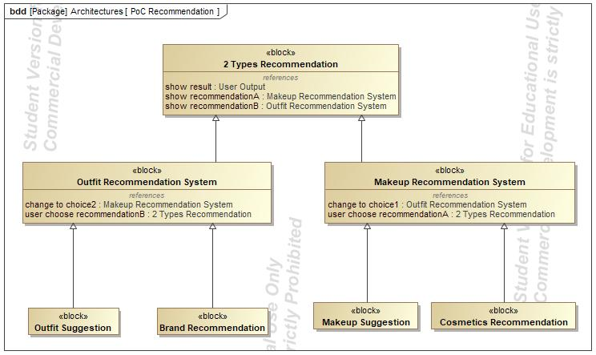

1. Diagram PoC Recommendation

## Mapping concept to PoC

**Diagram Specification>Documentation**

**In:** Proof of Concepts.Mapping concept to PoC

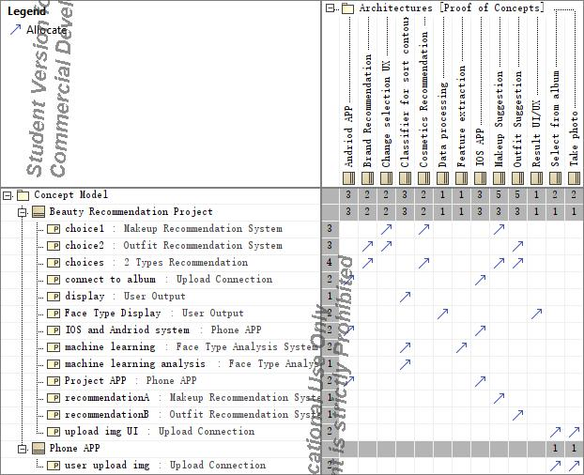

1. Diagram Mapping concept to PoC

## PoC Change recommendation system

**Diagram Specification>Documentation**

**In:** Concept Model.Data.Program Development.PoC Change recommendation system.PoC Change recommendation system

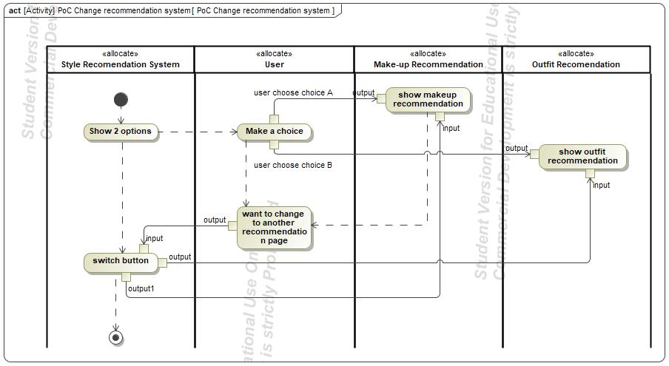

1. Diagram PoC Change recommendation system

## Beauty Recommendation Project

**Diagram Specification>Documentation**

**In:** Concept Model.Beauty Recommendation Project.Beauty Recommendation Project

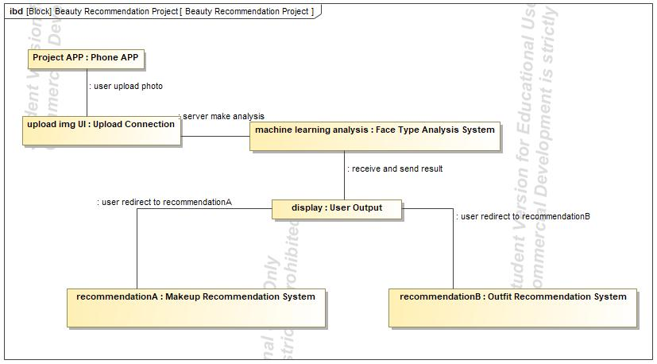

1. Diagram Beauty Recommendation Project

## Use Case

**Diagram Specification>Documentation**

**In:** Proof of Concepts.Functions.Use Case

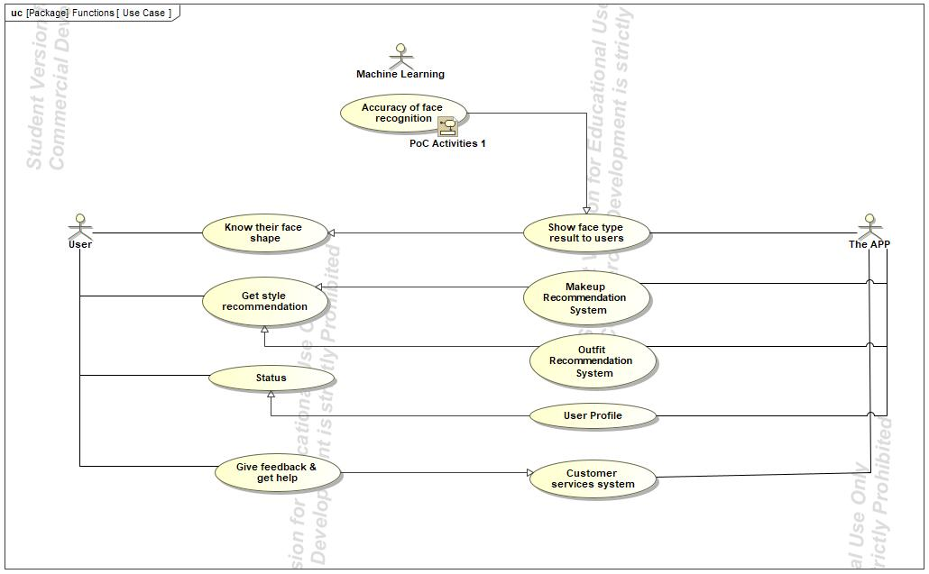

1. Diagram Use Case

## Concept Model

**Diagram Specification>Documentation**

**In:** Concept Model.Concept Model

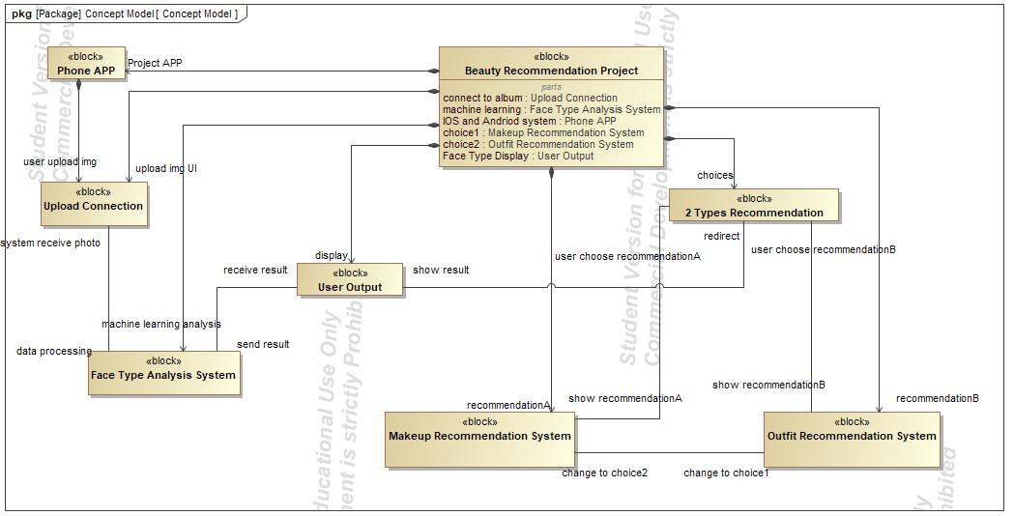

1. Diagram Concept Model

## Table of Ideas and Assumptions

**Diagram Specification>Documentation**

**In:** Concept Model.Data.Table of Ideas and Assumptions

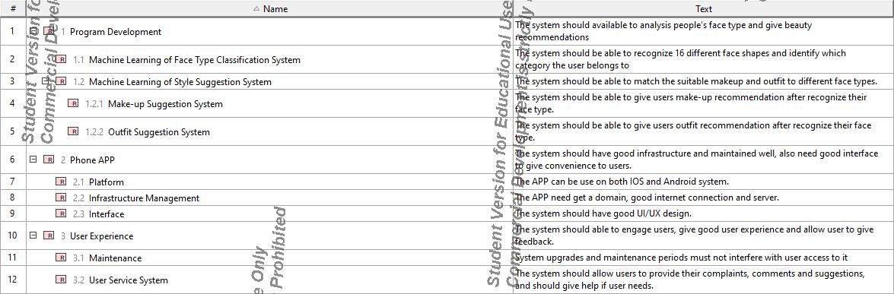

1. Diagram Table of Ideas and Assumptions

## PoC Service Activities

**Diagram Specification>Documentation**

**In:** Proof of Concepts.Services.PoC Service Activities.PoC Service Activities

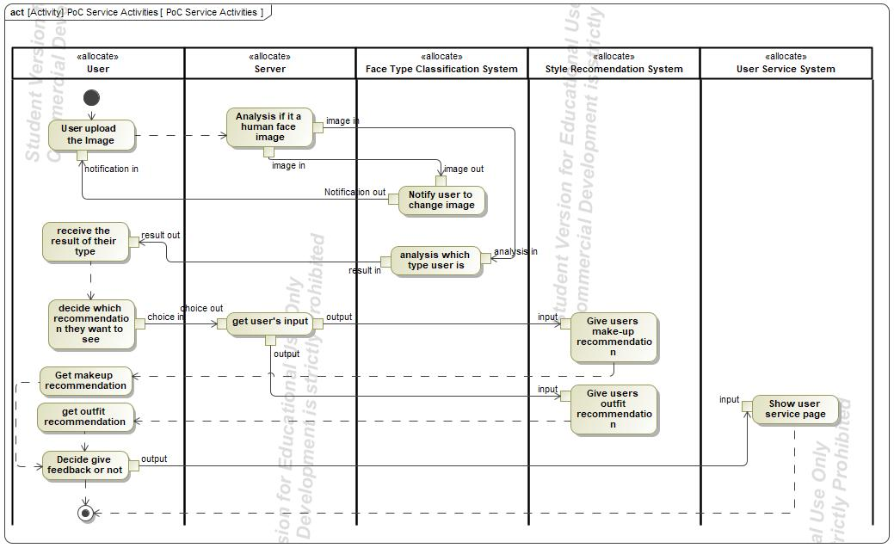

1. Diagram PoC Service Activities

## PoC Blocks

**Diagram Specification>Documentation**

**In:** Proof of Concepts.Architectures.PoC Blocks

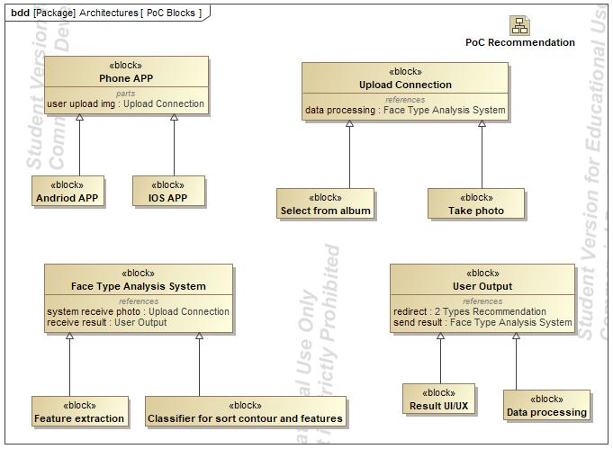

1. Diagram PoC Blocks

## Concepts Template Structure

**Diagram Specification>Documentation**

**In:** Concept Model.Concepts Template Structure

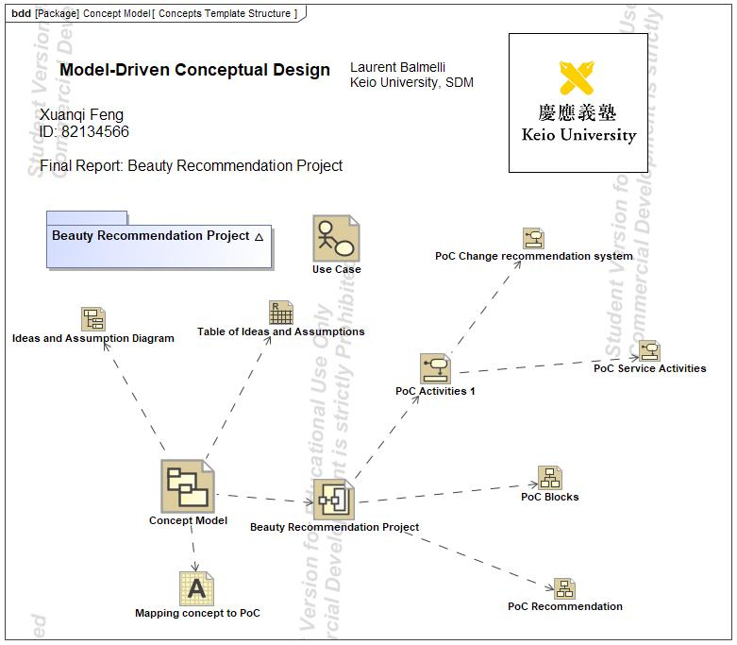

1. Diagram Concepts Template Structure

## PoC Activities 1

**Diagram Specification>Documentation**

**In:** Proof of Concepts.Functions.PoC Activities 1.PoC Activities 1

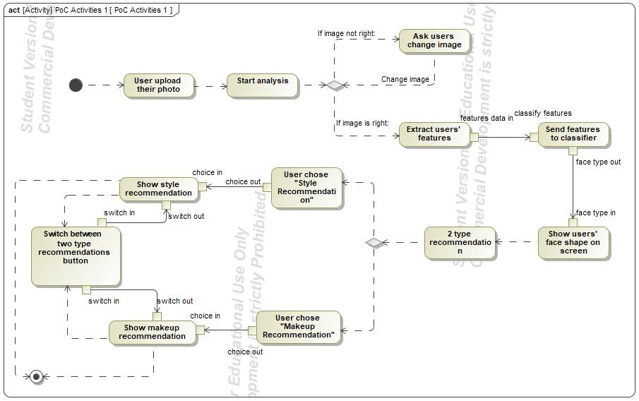

1. Diagram PoC Activities 1

## Ideas and Assumption Diagram

**Diagram Specification>Documentation**

**In:** Concept Model.Data.Ideas and Assumption Diagram

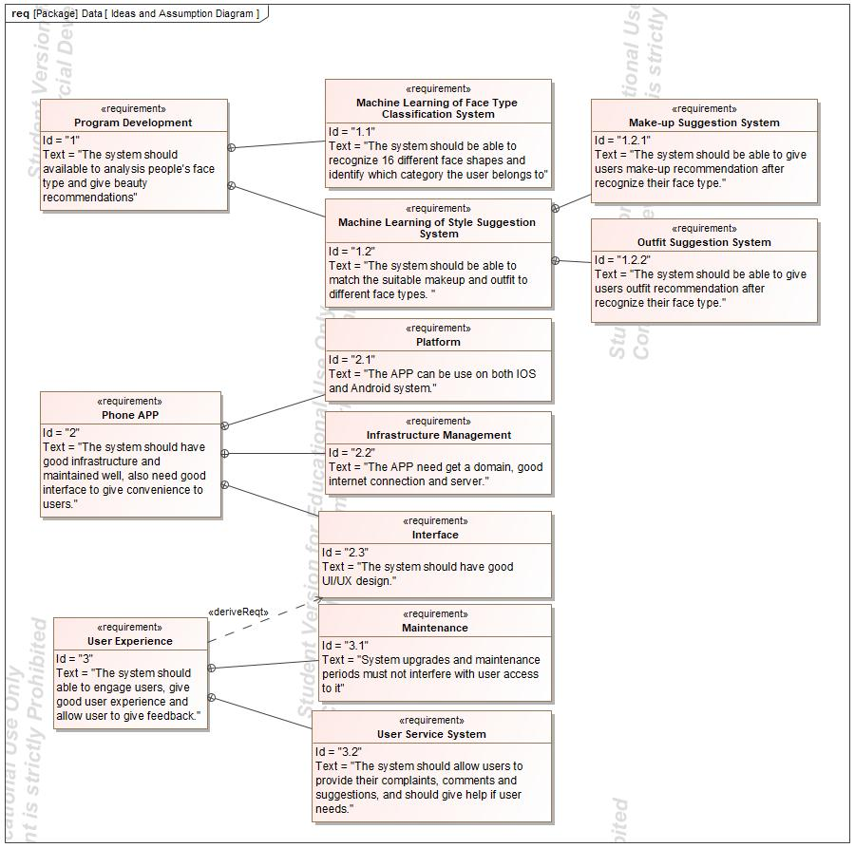

1. Diagram Ideas and Assumption Diagram

# Concept Use-Cases

|  |
| --- |
| **UseCase** |
| Accuracy of face recognition |
| Customer services system |
| Get style recommendation |
| Give feedback & get help |
| Know their face shape |
| Makeup Recommendation System |
| Outfit Recommendation System |
| Show face type result to users |
| Status |
| User Profile |

## Actor Summary

|  |  |
| --- | --- |
| **Primary Actor** | **Use Cases** |
| Machine Learning |  |
| The APP | * Customer services system      * Makeup Recommendation System      * Outfit Recommendation System      * Show face type result to users      * User Profile |
| User | * Get style recommendation      * Give feedback & get help      * Know their face shape      * Status |

## Use Case: Use Case Diagram



## Accuracy of face recognition Use Case

|  |  |  |  |
| --- | --- | --- | --- |
| **Use Case Name** | Accuracy of face recognition | ID |  |
| **Complexity** | Average Complexity | | |
| **Description** |  | | |
| **Actors** | See parent class for actor associations | | |
| **Goal** |  | | |
| **Assumption** | No assumption for this use case. | | |
| **Non Functional Requirements** | No non-functional requirement for this use case. | | |

|  |  |
| --- | --- |
| **Relations** | |
| **Association** | No direct association to this use case. Check the parent use case (see Generalization below.) |
| **Generalization** | * Show face type result to users UseCase |

## Customer services system Use Case

|  |  |  |  |
| --- | --- | --- | --- |
| **Use Case Name** | Customer services system | ID |  |
| **Complexity** | Average Complexity | | |
| **Description** |  | | |
| **Actors** | * The APP | | |
| **Goal** |  | | |
| **Assumption** | No assumption for this use case. | | |
| **Non Functional Requirements** | No non-functional requirement for this use case. | | |

|  |  |
| --- | --- |
| **Relations** | |
| **Association** | * The APP Actor |
| **Generalization** |  |

## Get style recommendation Use Case

|  |  |  |  |
| --- | --- | --- | --- |
| **Use Case Name** | Get style recommendation | ID |  |
| **Complexity** | Average Complexity | | |
| **Description** |  | | |
| **Actors** | * User | | |
| **Goal** |  | | |
| **Assumption** | No assumption for this use case. | | |
| **Non Functional Requirements** | No non-functional requirement for this use case. | | |

|  |  |
| --- | --- |
| **Relations** | |
| **Association** | * User Actor |
| **Generalization** |  |

## Give feedback & get help Use Case

|  |  |  |  |
| --- | --- | --- | --- |
| **Use Case Name** | Give feedback & get help | ID |  |
| **Complexity** | Average Complexity | | |
| **Description** |  | | |
| **Actors** | * User | | |
| **Goal** |  | | |
| **Assumption** | No assumption for this use case. | | |
| **Non Functional Requirements** | No non-functional requirement for this use case. | | |

|  |  |
| --- | --- |
| **Relations** | |
| **Association** | * User Actor |
| **Generalization** | * Customer services system UseCase |

## Know their face shape Use Case

|  |  |  |  |
| --- | --- | --- | --- |
| **Use Case Name** | Know their face shape | ID |  |
| **Complexity** | Average Complexity | | |
| **Description** |  | | |
| **Actors** | * User | | |
| **Goal** |  | | |
| **Assumption** | No assumption for this use case. | | |
| **Non Functional Requirements** | No non-functional requirement for this use case. | | |

|  |  |
| --- | --- |
| **Relations** | |
| **Association** | * User Actor |
| **Generalization** |  |

## Makeup Recommendation System Use Case

|  |  |  |  |
| --- | --- | --- | --- |
| **Use Case Name** | Makeup Recommendation System | ID |  |
| **Complexity** | Average Complexity | | |
| **Description** |  | | |
| **Actors** | * The APP | | |
| **Goal** |  | | |
| **Assumption** | No assumption for this use case. | | |
| **Non Functional Requirements** | No non-functional requirement for this use case. | | |

|  |  |
| --- | --- |
| **Relations** | |
| **Association** | * The APP Actor |
| **Generalization** | * Get style recommendation UseCase |

## Outfit Recommendation System Use Case

|  |  |  |  |
| --- | --- | --- | --- |
| **Use Case Name** | Outfit Recommendation System | ID |  |
| **Complexity** | Average Complexity | | |
| **Description** |  | | |
| **Actors** | * The APP | | |
| **Goal** |  | | |
| **Assumption** | No assumption for this use case. | | |
| **Non Functional Requirements** | No non-functional requirement for this use case. | | |

|  |  |
| --- | --- |
| **Relations** | |
| **Association** | * The APP Actor |
| **Generalization** | * Get style recommendation UseCase |

## Show face type result to users Use Case

|  |  |  |  |
| --- | --- | --- | --- |
| **Use Case Name** | Show face type result to users | ID |  |
| **Complexity** | Average Complexity | | |
| **Description** |  | | |
| **Actors** | * The APP | | |
| **Goal** |  | | |
| **Assumption** | No assumption for this use case. | | |
| **Non Functional Requirements** | No non-functional requirement for this use case. | | |

|  |  |
| --- | --- |
| **Relations** | |
| **Association** | * The APP Actor |
| **Generalization** | * Know their face shape UseCase |

## Status Use Case

|  |  |  |  |
| --- | --- | --- | --- |
| **Use Case Name** | Status | ID |  |
| **Complexity** | Average Complexity | | |
| **Description** |  | | |
| **Actors** | * User | | |
| **Goal** |  | | |
| **Assumption** | No assumption for this use case. | | |
| **Non Functional Requirements** | No non-functional requirement for this use case. | | |

|  |  |
| --- | --- |
| **Relations** | |
| **Association** | * User Actor |
| **Generalization** |  |

## User Profile Use Case

|  |  |  |  |
| --- | --- | --- | --- |
| **Use Case Name** | User Profile | ID |  |
| **Complexity** | Average Complexity | | |
| **Description** |  | | |
| **Actors** | * The APP | | |
| **Goal** |  | | |
| **Assumption** | No assumption for this use case. | | |
| **Non Functional Requirements** | No non-functional requirement for this use case. | | |

|  |  |
| --- | --- |
| **Relations** | |
| **Association** | * The APP Actor |
| **Generalization** | * Status UseCase |